Assignment1 – Ben Smerd 22072922

* **State-space structure**

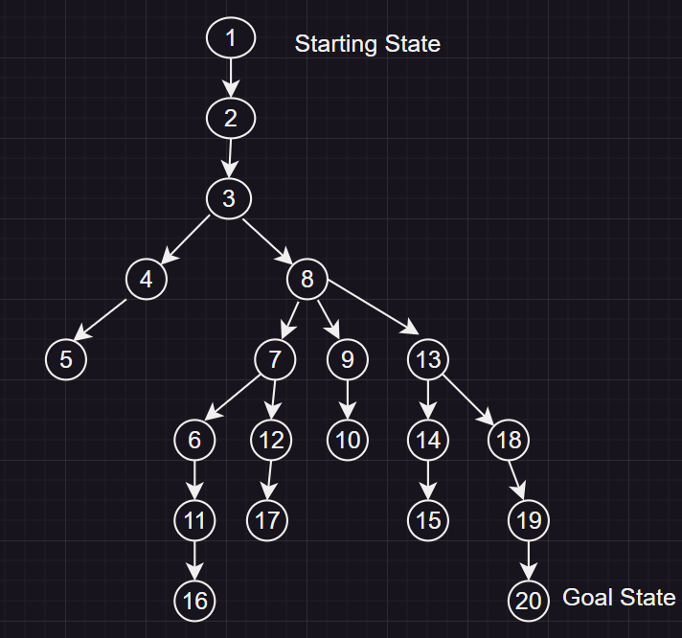

* **Depth-first search**

1. Open=[1];closed=[]
2. Open=[2];closed=[1]
3. Open=[3];closed=[2,1]
4. Open=[4,8];closed=[3,2,1]
5. Open=[5,8];closed=[4,3,2,1]
6. Open=[8];closed=[5,4,3,2,1]
7. Open=[7,9,13];closed=[8,5,4,3,2,1]
8. Open=[6,12,9,13];closed=[7,8,5,4,3,2,1]
9. Open=[11,12,9,13];closed=[6,7,8,5,4,3,2,1]
10. Open=[16,12,9,13];closed=[11,6,7,8,5,4,3,2,1]
11. Open=[12,9,13];closed=[16,11,6,7,8,5,4,3,2,1]
12. Open=[17,9,13];closed=[12,16,11,6,7,8,5,4,3,2,1]
13. Open=[9,13[;closed=[17,12,16,11,6,7,8,5,4,3,2,1]
14. Open=[10,13];closed=[9,17,12,16,11,6,7,8,5,4,3,2,1]
15. Open=[13];closed=[10,9,17,12,16,11,6,7,8,5,4,3,2,1]
16. Open=[14,18];closed=[13,10,9,17,12,16,11,6,7,8,5,4,3,2,1]
17. Open=[15,18];closed=[14,13,10,9,17,12,16,11,6,7,8,5,4,3,2,1]
18. Open=[18];closed=[15,14,13,10,9,17,12,16,11,6,7,8,5,4,3,2,1]
19. Open=[19];closed=[18,15,14,13,10,9,17,12,16,11,6,7,8,5,4,3,2,1]
20. Open=[20];closed=[19, 18,15,14,13,10,9,17,12,16,11,6,7,8,5,4,3,2,1]
21. Goal reached [20]
    * Path: 1->2->3->4->5->8->7->6->11->16->12->17->9->10->13->14->15->18->19->20
    * Discussion: Depth-first search will go down to the bottom of each branch of a child node of a parent, before moving on to a sibling branch of the same parent node.

* **Breadth-first search**

1. Open=[1];closed=[]
2. Open=[2];closed=[1]
3. Open=[3];closed=[2,1]
4. Open=[4,8];closed=[3,2,1]
5. Open=[8,5];closed=[4,3,2,1]
6. Open=[5,7,9,13];closed=[8,4,3,2,1]
7. Open=[7,9,13];closed=[5,8,4,3,2,1]
8. Open=[9,13,6,12];closed=[7,5,8,4,3,2,1]
9. Open=[13,6,12,10];closed=[9,7,5,8,4,3,2,1]
10. Open=[6,12,10,14,18];closed=[13,9,7,5,8,4,3,2,1]
11. Open=[12,10,14,18,11];closed=[6,13,9,7,5,8,4,3,2,1]
12. Open=[10,14,18,11,17];closed=[12,6,13,9,7,5,8,4,3,2,1]
13. Open=[14,18,11,17];closed=[10,12,6,13,9,7,5,8,4,3,2,1]
14. Open=[18,11,17,15];closed=[14,10,12,6,13,9,7,5,8,4,3,2,1]